Japan
This is the flag
of Japan.

Japan
This is the flag
of Japan.

Japan
__________________________________________
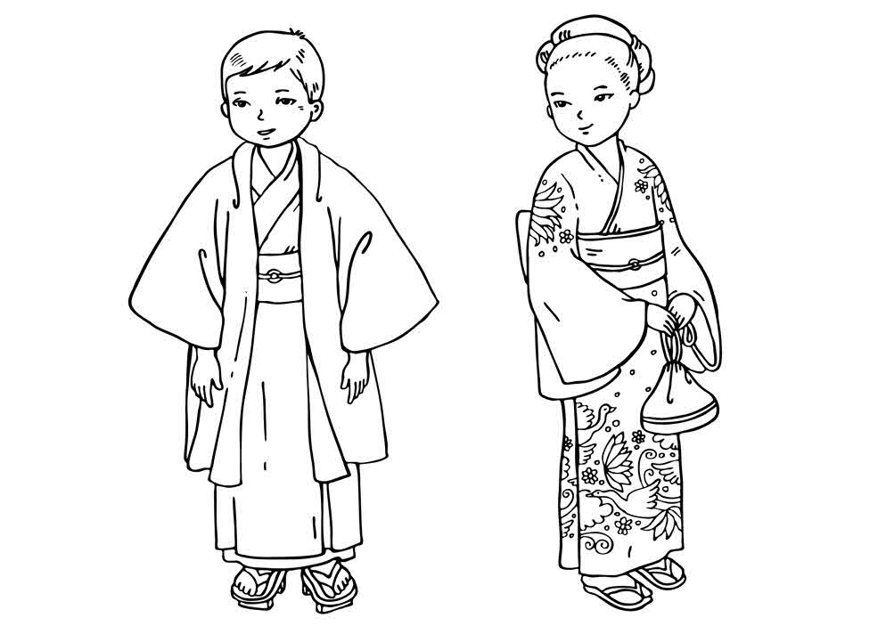

The kimono is worn in Japan.

__________________________________________

The kimono is worn in Japan.

